**Mars Bar Tectonics** Name ____________________

**You will need a fun-size Mars Bar for this activity.**

**Part A: Getting Ready**

1. Use your fingernail to make small cracks in the surface of your “Earth” or Mars bar. Place on a paper towel.
2. What do we call the cracks in the Earth’s surface? __________________________
3. What do we call the large pieces of Earth’s crust? __________________________
4. Compare the Mars Bar to the Earth's structure. Label the parts of the Mars Bar to correspond with the layers of the Earth.

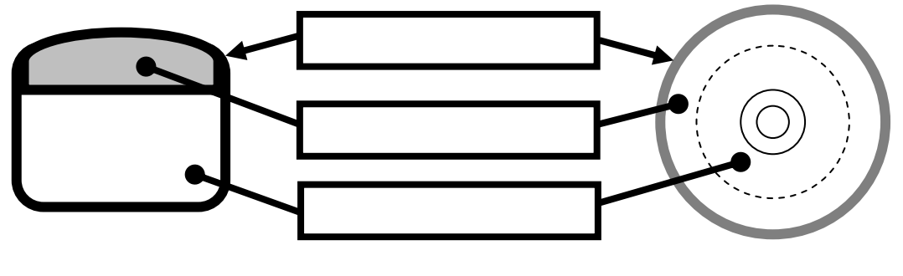

1. Which layer of the Earth is "missing" in the Mars Bar? _______________________

**Part B: Observing Forces**

1. Gently pull the two ends of the Mars Bar away from each other (don’t let it tear completely).
2. What do you observe happening? _______________________________________
3. At what type of plate boundary would this action occur? ______________________
4. What natural events/structures would occur at such boundaries? ________________________________________________________________________________________________________________________________
5. Gently push the end of the Mars bar towards each other.
6. What do you observe as you apply this force? ______________________________
7. At what type of plate boundary would this force occur? ______________________
8. What natural events/structures would occur at such boundaries? ________________________________________________________________________________________________________________________________
9. Gently push the ends of the Mars bar parallel to each other, in opposite directions.
10. What do you observe happening as you apply this force? ________________________________________________________________
11. At what type of plate boundary would this force occur? ______________________
12. What natural event would occur at such boundaries? ________________________________________________________________________________________________________________________________